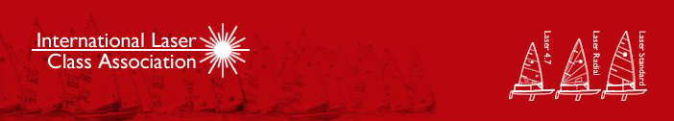

Entries Still Open for 2013
Laser Radial Youth World Championship in Oman!

December 11th 2013

NB: please forward this to your members and include on your websites!
Click here for a video on the Youth Worlds with interviews from Robert Scheidt,Phillip Buhl, Jean-Baptiste Bernaz and others...!
After a thrilling week of Laser World Championship racing in Oman, Robert Scheidt was crowned 2013 Laser World Champion for the ninth time on Saturday proclaiming this Laser World Championship title as his best so far. Next up are the Laser Masters' World Championships from 28 November-7 December, swiftly followed by the Laser Radial Youth World Championships from 29 December to 3 January!
ENTRIES FOR THE YOUTH WORLD CHAMPIONSHIPS ARE STILL OPEN - TO SIGN UP GO TO: Laser Radial Youth Championship 2013
The Laser Radial Youth World Championships are regarded among Olympic sailors as one of the most valuable platforms for success in sailing. British sailor
Sir Ben Ainslie started in the Laser Radials as did Olympic gold medallist Tom Slingsby.
Many of the current fleet of Laser sailors who competed in the World Championship in Oman, claim they owe their success to their Laser Radial campaigns as teenagers -
This is what they had to say:
Phillip Buhl, bronze medallist in the 2013 Laser Worlds, won a silver medal at the Laser Radial Youth Championships in Douarnenez in 2008: ''For young ambitious sailors, it is important to gather experience at international regattas,'' he said. ''Here in Oman it is lovely. There is wind every day but it is rarely extreme. The sun shines and the marina is absolutely perfect for regattas like this because everything is close by. I recommend that youth sailors come here and take part - you can learn a lot."
Croatia's Tonci Stipanovic, who was Laser Radial Youth World Champion in 2003, urged young sailors to jump on the Laser Radial Youth Worlds expressway in December: "It really helped me in that it made me push for more success," he said. "If I had not competed in the Laser Radial Youth class, there is no way I would be here at the Laser World Championships now. I would have had to go in a completely different direction."
Britain's top Laser sailor Nick Thompson also started in the Radials: "The Laser Radials were a huge stepping stone for me. I came out of my junior classes and if you want to do single-handed sailing to a high level and are big, the Laser Radial is the best option. It provides the perfect opportunity to master the boat and when you get into the full rig, there isn't a huge difference. If you do well in the Radial, you will be alright in the full rig and if you do well in the Radials, chances are you will get noticed and be given a chance at a higher level."
And from the 2013 Laser World Champion himself, Robert Scheidt: "This Laser regatta is a must, you have to come here if you want to achieve something in sailing. It is a great start for these guys."
Click here to watch a special interview with 2013 Laser World Champion Robert Scheidt

